**Abstract Metadata in Public Broadcasting**

**Part 4: Deals and Rights**

Version 2.1

May 2017

# 

## 

## 

## Table of Contents

Introduction

Goal

Terms and Definitions

Core Metadata Concepts

Structural Metadata Overview

Deals

Deal UID

Deal Reference ID

Deal Name

Relates to Content

Rights Holder Organization

Rights Grantee Organization

Rights Clauses

Rights Type

Extant Rights Window

Usage Model

Effective Usage Window

Workflow

## 

## Introduction

This part discusses how the metadata associated with broadcasting deals, rights, permissions, and content visibility is represented. This is the fourth part of a series of documents concerning the Interconnection System’s metadata system. The other documents in this series are as follows:

* **Part 1: Introduction to Abstract Metadata in Public Broadcasting**  
  This part introduces the Interconnection System and the need for an abstract hierarchical metadata system.
* **Part 2: Specific Fields and Values**  
  This part describes the core abstract metadata models that compose the content library.
* **Part 3: Segmentation Metadata**  
  This part explains the metadata that provides detailed information about media content.

### Goal

In previous iterations of the Interconnection System, Deals and Rights were dealt with by systems outside of the Interconnection System.

The newest iteration of the Interconnection System acts as a commonly accessible repository that passively captures and distributes information about Deals and Rights in a standardized format. The enforcement of the captured Deals and Rights still relies on human interpretation and external Rights Management Systems. However, by giving the metadata system parseable data to calculate usage windows, PBS can establish an Interconnection System rights model that can drive future automation.

### Terms and Definitions

This document specifically discusses deals and rights in the Interconnection System. The following terms are used throughout and should be interpreted with the definitions below.

Actors:

* **Content providers** (or distributors) are the organizations that hold the creative license and rights for content created or obtained to be broadcasted.
* **Content consumers** are the organizations that wish to use content, such as broadcasting stations within PBS, PDP (program differentiation plan) stations, and independent broadcasting stations.

Systems:

* The **Interconnection System** (IXS) is responsible for calculating and enforcing the Delivery Window of content from a content provider to a content consumer. It also sends outbound notifications when the content provider makes changes to a Usage Window.
* The **Station Traffic System** is responsible for scheduling the delivery of content based on the Delivery Window and for enforcing the Rights Usage Window.
* **Rights Management Systems** are software used by the content provider to establish the Rights Usage Window. These systems hold the contract and legal information for a piece of content.
* The **Content Packaging System** is software used by the content provider to establish the Context Usage Windows.
* **Feed schedule systems** are software that control the feed schedule for content providers.

Terms:

* **Broadcasting rights** are granted by **content providers** to a broadcasting station (either directly or via a distributor) to air a specific program on a station’s channel or channels. These rights describe how and how often the rights holder can use the content.

The abstract models that will be defined in following sections are Rights, Deals, and Usage Windows.

## 

## 

## Core Metadata Concepts

### Structural Metadata Overview

The abstract models discussed in this section include Deals, Rights, and the Effective Usage Window.

Their relationship to abstract content metadata concepts (Episode/OTO, Release, Manifestation) and Organizations are shown below:

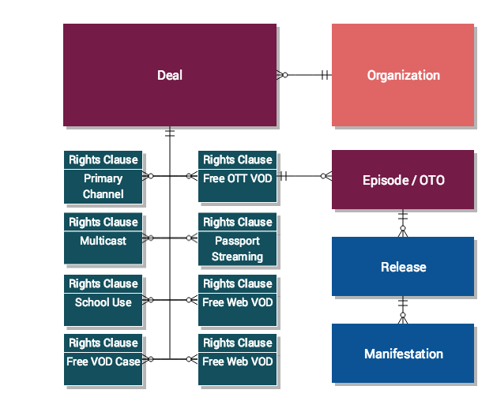

### Deals

**Deals** are constructed during the Acquisition phase of content development cycle. They represent specific usage agreements between the content providers and content consumers about a specific piece of content, such as an Episode, OTO, Release, or Manifestation.

Before a Deal can be created, the metadata for the content in question and the Organizations involved must already be registered to the metadata system.

Dealsact as containers for the following relationships:

* Relevant Organizations (Content providers and consumers)
  + A Deal can support multiple content providers. As long as multiple providers do not try to distribute the same piece of content simultaneously to the same station on the IXS, there should be no conflict.
  + Multiple content providers can still distribute the same piece of content at the same time to the same station as long as they are not all using the IXS.
* Relevant Abstract Content Model (Specific IDs for Episode, OTO, Release, etc.)

#### Deal UID

The universal Identification number for the Deal. This allows the IXS to associate Episodes, Usage Windows, and Underwriting with this particular Deal. The format for a UID is an URN string, such as fe393d2a-0d5b-4366-b0ea-7aa8ecf715f2.

#### Deal Reference ID

This field captures the local ID given to a Deal by the content provider’s rights management system. The format for this ID may vary from system to system.

#### Deal Name

The name of the deal. For example, the Deal name for the show History of Bikes could be History of Bikes.

#### Rights Holder Organization

This field links to the content provider’s profile.

### Rights Clauses

Rights are represented as one or more clauses. A Rights Clause defines how content can be used by licensee organizations.

A Rights Clause is defined by the following metadata fields:

* Relates to Content
* Rights Grantee Organization
* Rights Type
* Extant Rights Window
* Usage Model
* Geographic Region

The relationship between these metadata fields is represented in Figure 1.

##### Figure 1: Rights Clause Metadata

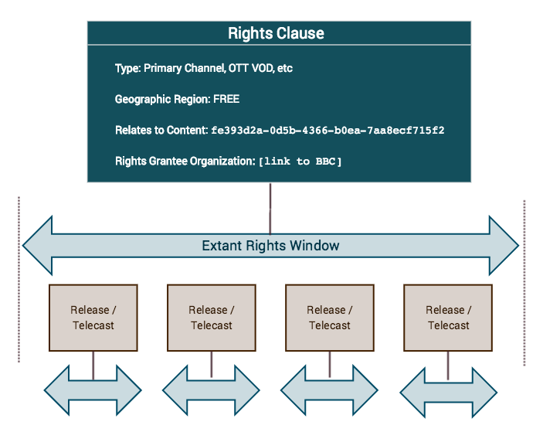

#### Extant Rights Window

This is the Start Date/Time and End Date/Time for a Rights Clause in a format consistent with [ISO 8601](http://www.iso.org/iso/home/standards/iso8601.htm) (YYYY:MM:DD:HH:MM). The time zone should be set to the licensee’s local time. The Extant Rights Window should include any blackout windows.

In cases where there is no End Date, the Extant Rights Window can be set to Perpetuity.

#### Geographic Region

This field represents the geographic region that is permitted or excluded by the Rights Clause. In the case where there are no geographic restrictions, this clause is omitted.

Attributes of the Geographic Region are as follows:

* **List of Geographic Regions**: This attribute captures a list of relevant geographic regions.
* **Inclusive / Exclusive**: This boolean flag determines if the list of geographic regions are allowed or not allowed. Often, the Exclusive flag is used when the range of “allowed” geographic regions are much larger than the “not allowed” regions.
* **Type of Geographic Regions**: This attribute defines the resolution of the geographic regions. Acceptable values are:
  + Country
    - Based on [ISO 3166-1 alpha 2](https://en.wikipedia.org/wiki/ISO_3166-1_alpha-2#Officially_assigned_code_elements)
  + State
    - Based on [ISO 3166-2](https://en.wikipedia.org/wiki/ISO_3166-2#Current_codes)
  + Television Market Area (TMA)
    - Based on [FCC list](https://en.wikipedia.org/wiki/List_of_United_States_television_markets)

Some examples:

1. For U.S. based broadcast:
   1. Inclusive = True
   2. Type = Country
   3. List = US
2. For content only in a single TMA
   1. Inclusive = True
   2. Type = Television Market Area
   3. List = “Washington (Hagerstown, MD), DC”
3. For content only in a single State
   1. Inclusive = True
   2. Type = State
   3. List = NE

#### Relates to Content

#### A Deal concerns a specific abstract content model, such as an OTO, Episode, or Release. This field captures the UIDs of content models under that Deal.

#### Rights Grantee Organization

This field links to the content consumer’s profile. There may be multiple organizations.

#### Rights Type

Media can be exploited by the content consumer in different ways: broadcast, published, etc. The exact exploitation rights for a piece of media are generally defined in a legal agreement between the Content Provider (or Distributor) and the Content Consumer. The process of how that legal agreement is created is beyond the scope of this document; however, once that legal agreement is established and the exploitation rights are defined, the IXS metadata system will facilitate the exchange of that information in a precise, machine-readable format.

However, for the metadata system to work, the Content Provider and the Content Consumer must agree on unique terms that represent each exploitable content rights. These unique terms are represented by a **Rights Type** and consist of a simple string (1000 characters) that is considered opaque by the metadata system and merely passed along.

As of the writing of this document, a common set of exploitation rights for use in the Interconnection System is still being defined and will be documented independently from this series of documents concerning the Metadata model.

Some examples of **Rights Type** could be:

* Linear
  + Primary Channel
  + Multicast
  + Live Streaming
* Non-Linear (Video on Demand [VOD])
  + Free Cable
  + Free OTT
* Education
  + School Off-Air Recording
  + PBSLM

Once again, these Rights Types are included here merely as context for understanding the Metadata models.

#### Usage Model

Content providers must designate the usage of their content as one of the following three options: unlimited, release, or telecast. The usage model will define the **Rights Usage Window**.

An **Unlimited** model (Figure 2) means that the content consumer may use the content as many times as it wants within the Extant Rights Window. There may be blackout dates defined in the Extant Rights Window. The **Rights Usage Window** is the same as the **Extant Rights Window**.

##### Figure 2: Illustration of Unlimited Usage Model

##### 

A **Release** model (Figure 3) means that the content consumer can trigger a predefined duration window of air time for a specified number of times. The **Rights Usage Window** must be defined with a Start/End Date and Time consistent with [ISO 8601](http://www.iso.org/iso/home/standards/iso8601.htm) (YYYY:MM:DD:HH:MM); alternatively, the **Rights Usage Window** may be defined as a Start Date and Time and a Duration.

##### Figure 3: Illustration of Release Usage Model

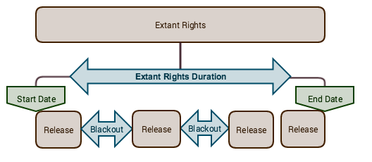

For example, a Rights Clause for History of Bikes may stipulate that the content consumer may have 3 Releases, and each Release is defined as 7-day window. The consumer may choose to trigger a Release window on January 17. History of Bike thus airs on January 17, and for the seven days after January 17, the consumer may run History of Bikes as many times as desired. Then, after January 24, the consumer has to use one more of its two remaining Releases in order to run History of Bikes again.

A **Telecast** model (Figure 4) means that a consumer can broadcast the specified content for a specified number of times. Unlike a Release usage model, a Telecast usage model does not include a time window for unlimited runs. Telecasts are one-time-only uses. The **Rights Usage Window** is the same as the runtime of the program.

##### Figure 4: Illustration in Telecast Usage Model

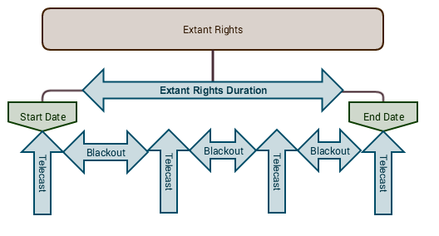

For example, the Rights Clause may stipulate that a consumer may telecast *History of Bikes* 4 times within the Extant Rights Window of January 2014 and January 2016.

Thus, a valid usage scenario be:

* *The consumer telecasts* History of Bikes *on February 2 2014, June 13 2014, February 4 2015, and May 9 2015.*

Invalid usage scenarios include the following:

* *The consumer telecasts* History of Bikes *on February 2 2014, June 13 2014, February 4 2015, and May 9 2015. The content consumer then attempts to telecast* History of Bikes *one more time on December 13 2015. This scenario violates the number of uses listed in the Rights Clause.*
* *The consumer telecasts* History of Bikes *three times between January 2014 and January 2016. It then attempts to telecast* History of Bikes *for the fourth time on February 13 2016. Because February 13 2016 is outside of the Extant Rights Window, this is an invalid use.*

### Effective Usage Window

Up to this point, the Rights discussed in this document have centered on the abstract core models. However, the metadata system also includes metadata for Releases (which include Supplemental Media) and Manifestations, the curated compilations and tangible assets that are actually exploited by the Content Consumer. The Effective Usage Window describes when a Release and its Manifestations can be used, depending on the Supplemental Media packaged with the Release and according to the associated Rights.

Upon creation, a Release is a combination of Primary Media (or essence) and Supplemental Media (underwriting, system cues, brand spots, teasers; these are defined further in Part 5 of this document series). Often, the included Supplemental Media reference other programs that occur on a linear feed. These programs could have occurred in the past or are scheduled to occur in the future, but the Supplemental Media must be in the proper temporal location to make sense. For example, Past Time Teasers (“Previously on Downton Abbey…”) and Next Time Teasers (“Next time on Downton Abbey….”) are Supplemental Media that are only valid and relevant for the end consumer when put in a linear context.

The consumable time window in a linear feed is known as the **Context Usage Window**. This means that if the Release (and associated Manifestation files) are scheduled in the linear feed outside of the **Context Usage Window**, the content will not make sense to the end consumer if he/she were consuming the media in a linear fashion.

The Context Usage Window is combined with the Rights Usage Window of the Release’s parent abstract model to calculate the start and end date and time that constitutes allowed usage. The result of this calculation is the **Effective Usage Window**.

The Rights Usage and Context usage windows are illustrated in Figure 5. Their overlap is the Effective Usage Window.

##### Figure 5: Time Windows

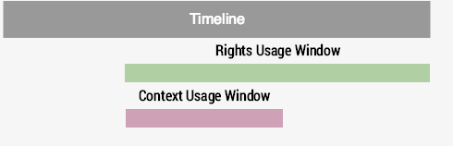

## Workflow

As of the publication of this document, the workflow in this section represents a possible workflow based on plans for how the Interconnection System (IXS) could work in the future. The IXS may not operate in this manner, but due to the nature of Rights and Usage, there are numerous systems outside of the MOS that are relevant to the end-to-end workflow.

1. Content consumer negotiates agreement.
   * Content provider and Content consumer agree on terms and conditions.
   * Provider records legal agreement in the Provider’s Rights Management System.
2. Content provider enables content delivery.
   * Creates a Deal in MOS system of record (TBD) and associates it with content consumers.
   * Creates one or more Rights Clauses
3. Content Provider updates Rights based on events.
   * Some Rights Usage Window are based on Events in time (e.g. NPS Feed).
   * Content Provider / Distributor uses data in their own rights management system to calculate start/end dates.
   * Updates Rights Usage Window for event-based Rights Clause.
4. Content consumer schedules content to be broadcasted.
5. Content provider prepares content.
   * Creates Release which includes Supplemental Media.
   * Calculates Context Usage Window
   * Calculates Effective Usage Window
6. Provider uploads content.
   * Uploads content to IXS.
   * Establishes Effective Usage Window start/end timestamp.
7. IXS calculates Delivery Window (outside scope of this document).
8. IXS delivers content as long as current time is in Delivery Window.